Risk assessment for the Ultramicrotome EM UC7

Date: 2019-02-22
Completed by: M. K. Tracy Hong Lin

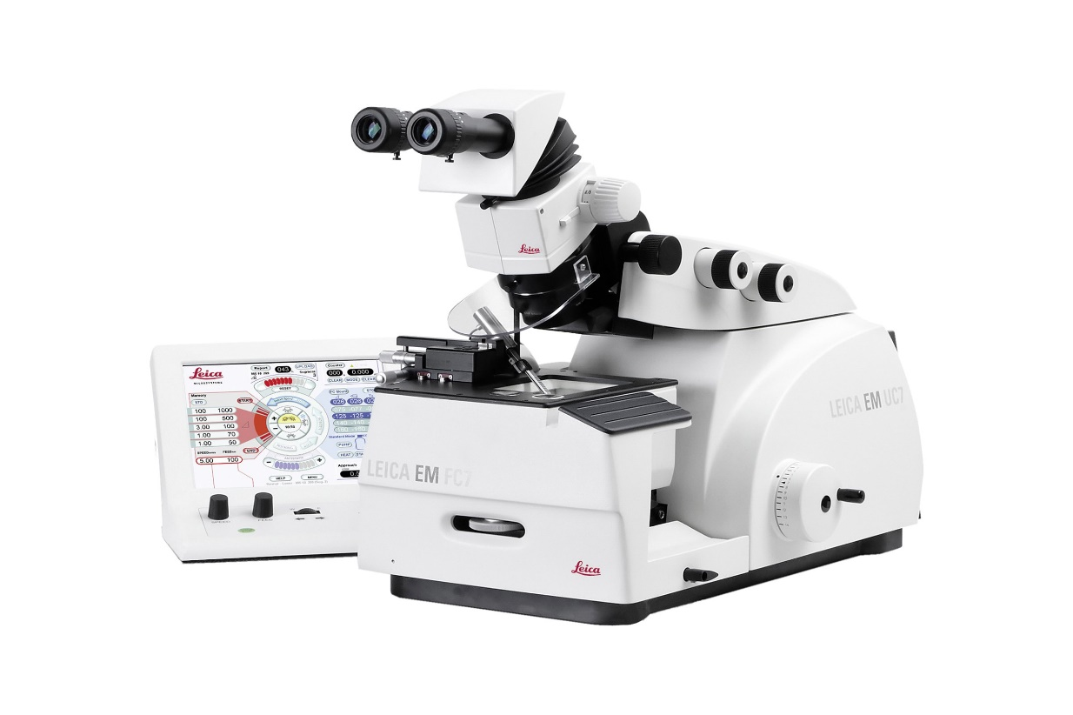

1) Review of the machine:
(Description of the machine/process, how it works and the work flow)
The instrument is used for ultra-thin sectioning of sample embedded in resin block with a feed range of 1 nm up to 15 µm. Glass or diamond knife can be used for ultra sectioning of samples.

The sectioning procedure is as follows:
- Insert specimen holder in the segment arc of the EM UC7 and tighten it
- If sample was trimmed with the Leica EM Trim 2, set angle to 0˚
- Insert a 35˚ diamond knife to its end stop and tighten it
- Set the clearance angle to 6˚
- Manually approach the knife towards the sample and clamp the knife block
- For ergonomic posture, adjust the viewing angle with “ErgoWedge” of the observation system
- When using a diamond knife, set the observation system in the centre click stop position. Thus achieving the optimum approach accuracy
- Orientate knife in the east-west direction using the E-W coarse wheel
- Always focus on the knife edge
- For precise approach, switch on the backlight only
- Watch the “light-gap” to check the alignment and the distance
- Set the cutting window
- Move the sample below the knife
- Switch on the top light and fill trough with distilled water
- Make sure the knife edge is well contacted with water
- Adjust water level until it becomes silvery
- Set feed at ~50nm
- To avoid wetting the block face, start at high cutting speed e.g. 8mm/sec
- At the first section, reduce speed ~2mm/sec and feed <30nm
- Sectioning behavior will be improved by lowering the water level
- Manipulate sections with an eyelash
- Check the section ribbon size with the perfect loop and separate ribbon until it is suitable for the grid
- Pick up ribbon with the perfect loop
- Pick up carbon coated grid with the perfect loop
- Remove water using a filter paper
- Slightly bend the perfect loop and separate grid with the help of an eyelash
- Store grid in a grid-box
Video of procedure can be seen on: https://www.leica-microsystems.com/products/sample-preparation-for-electron-microscopy/p/leica-em-uc7/showcase/

2) Risk:
(Description of the identified safety issues, does it involve chemicals, high voltage, RF, X-ray, laser, other?)
Risk of injury from sharp knives.
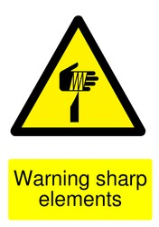

3) Identification
(Identification of the risks involved.)
Danger of injury when working with knives:
Extremely sharp knives are used for sectioning which can lead to injury when touched. The knives must therefore be mounted just before sectioning and must be removed from the knife holder after sectioning. When the knife is in the knife holder, the overhead illumination must be left switched-on.

Danger of injury during trimming of specimens:
Trimming of specimens can be carried out with razor blades. Extreme caution is advised when using razor blade and therefore Leica recommends to use a trimming machine.

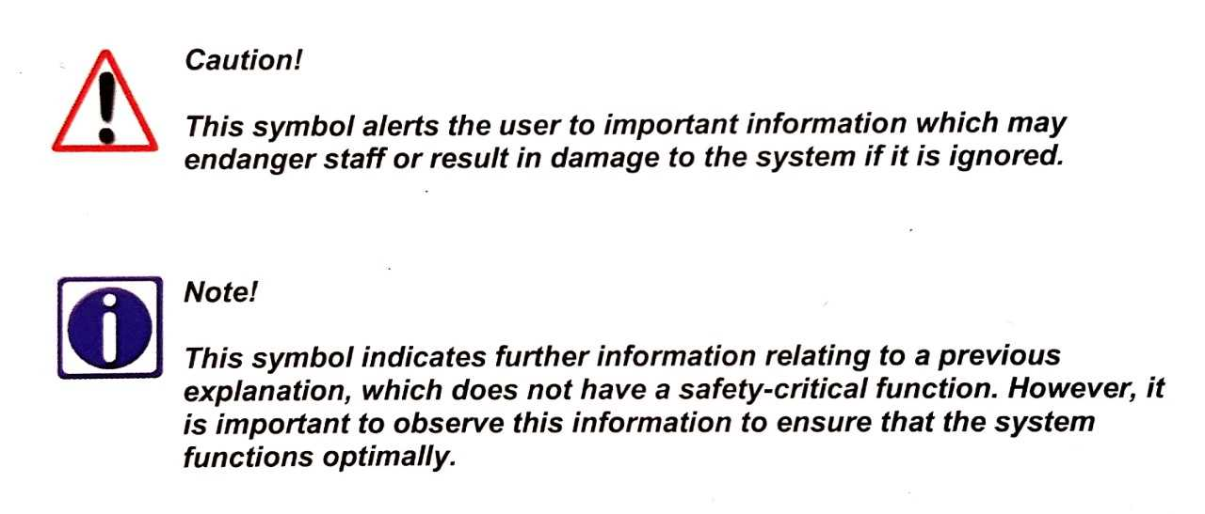

Precautionary Statement Response
The ultramicrotome must be used with care and one must be careful when handling sharp knives. Glass knives are free-standing and extremely sharp. They should be covered when not in use and should never be left exposed in the holder on the table.

4) Procedures-Consequences
(Describe how we avoid to be exposed to any danger from this equipment/process, during maintenance and normal use. And if this is not possible, then how we protect our self.)

5) Waste treatment
(What to do with the waste (if any))
In case the knife is damaged, it should be thrown away in the yellow waste container or contact technical staff.

