Objective

Batch name: Process template
This is an example process flow to be used as a template. It should contain
- The objective of the process
- Substrates/samples used in the flow. Both actual samples to be processed (device wafers) and monitor samples for the different process steps
- The Process flow main processes and steps
- Recommended: Figures illustrating the sample before and after each main process step.
How to use this template:
- Fill out the fields in the heading!
- Add process steps by using Quick Parts under Insert (your cursor should be located below the “Comments:”-line of the previous step).
Select the “Process Flow” item.
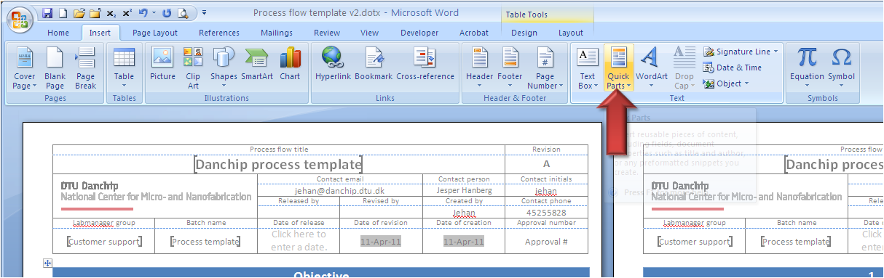
- Also other document parts can be inserted the same way: Substrate Info, Figure Table and TOC.

Substrates
Substrate | Orient. | Size | Doping/type | Polish | thickness | Box | Purpose | # | Sample ID
Silicon | <100> | 4” | n (Phos.) | DSP | 350±30µm |  | Device wafers
Silicon | <100> | 4” | n (Phos.) | DSP | 350±30µm |  | Dummy wafer
Comments: wafer bow on S1-S10 should be <2µm

- Preparation
Step Heading | Equipment | Procedure | Recipe/mask | Target±tol. | Comments
- Wafer selection | Wafer box | Take the wafers from the storage and put them in a wafer box.  Take the monitors from the box and put them in a sample tray. |  |  | Note the wafer IDs in the batch traveler
- Cleaning | 7-Up | Clean all wafers and monitors
- Inspection | lamp | Optical inspect wafers |  |  | Take new wafers if they cannot be well cleaned
- Start bake-out | 250°C oven | Place steel carrier with the wafers and monitors in the oven | Bake250 | >1 hour | 1 hour baking
Comments:Click here to enter text.

- Lithography
Step Heading | Equipment |  | Procedure | Recipe/mask | Target±tol. |  | Comments
- Surface treatment |  | HMDS oven | Load all wafers in oven for xx mins | Recipe 4 | >xx mins | Note time in traveler
- Clean spinner |  | Track 1 | Clean spinner nozzle and run the dummy wafer
- Coat wafers |  | Track 1 | Coat the sharp wafers  AZ5214e Novolac resist  Softbake on hotplate, 90°C, 60 sec | Recipe: PR1_5 | 1.5µm±  0.2µm | Resist thickness not checked
- Exposure |  | KS aligner | Align to flat.  Expose for xx sec | Mask: lines1
- Develop |  | Wet bench | Develop in YYYY for 120 sec |  | 120±10s | Note time in traveler
- Rinse |  | Wet bench | Rinse in DI water for 5 min |  | 300±30s
Comments:Click here to enter text.

Figures
Figure Caption | Figure | Step reference
- After development |  | 2 Lithography
Comments:Click here to enter text.

Contents
1 Preparation 2
1.1 Wafer selection 2
1.2 Cleaning 2
1.3 Inspection 2
1.4 Start bake-out 2
2 Lithography 2
2.1 Surface treatment 2
2.2 Clean spinner 2
2.3 Coat wafers 2
2.4 Exposure 2
2.5 Develop 2
2.6 Rinse 2

