Objective

Batch name: Process template
This process flow is a guideline on how to spin coat, expose, and develop SU-8 on 100 mm substrates such as Si, SiO₂ and Borofloat, using manual spin coater, mask aligner and submersion developer.

This is an example process flow to be used as a template. It should contain:
- The objective of the process
- Substrates/samples used in the flow - both actual samples to be processed (device wafers) and any monitor samples for the different process steps
- The Process flow main processes and steps
- Recommended: Figures illustrating the sample before and after each main process step

How to use this template (works only with the .dotx template file):
- Fill out the fields in the header
- Add process steps by using Quick Parts under Insert (your cursor should be located at the beginning of the next (empty) step)
Select the “Process Step” item
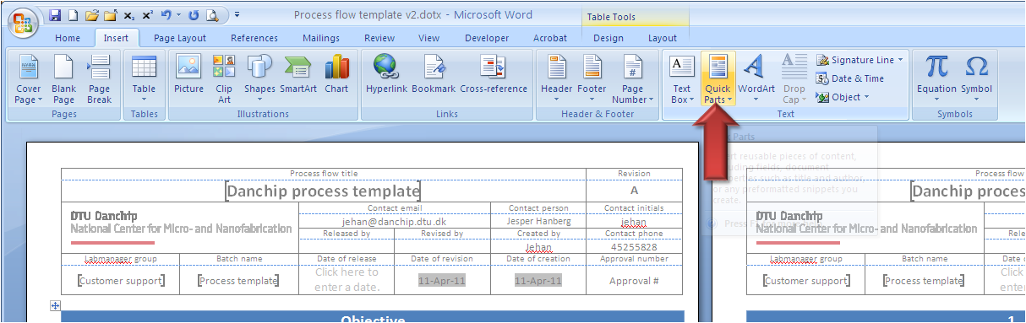
- Other document parts can be inserted the same way: Substrates, Figures, etc.
- The Content (TOC) on the last page is an option, but provides a nice overview for very long process flows

Substrates
Substrate | Orient. | Size |  | Doping/type | Polish | thickness | Box | Purpose | # | Sample ID
Silicon | <100> |  | 100 mm | n (Phos.) | SSP | 525 ±25 µm |  | Device wafers | 2 | S1-S2
Silicon | <100> |  | 100 mm | n (Phos.) | SSP | 525 ±25 µm |  | Test wafers | 1 | T1
Comments: Number of wafers is for illustration only

Figures
Figure | Caption | Step | Figure
 | After SiO2 dep  Not part of this process flow example | 2.1
 | After lithography | 3.5
 | After BHF etch  Not part of this process flow example | 4.1
 | After resist strip  Not part of this process flow example | 4.4
 | After lithography  Not part of this process flow example | 5.6
 | After metal deposition  Not part of this process flow example | 6.1
 | After lift-off  Not part of this process flow example | 6.2
Comments:Click here to enter text.

Step Heading | Equipment | Procedure | Comments
- Preparation |  |  | All wafers
- Wafer selection | Wafer box | Take the wafers from the storage and put them in a wafer box. | Note the wafer IDs in the batch traveler
- SiO₂ deposition |  |  | All wafers
  - Not part of this process flow example
- Lithography – standard |  |  | All wafers
- Surface treatment | 250C oven  Or  Oven:  HMDS – 2 | At least 30 min. Overnight bake for better dehydration  Vacuum bake with no HMDS  Recipe:  09 | This treatment takes a long time
- Syringe preparation | Fumehood 09 | Pour resist in syringe at least one day before use  Keep syringe in a resist storage cabinet | Mark syringe with resist type, your name, group name and date
- Coat wafers | Spin Coater: RCD8 | Resist:  SU8-2075  Automatic dispense system:  4 ml ≈ 8 sec @ 2 bar  Spin:  Target thickness: 100 µm  Gyrset: Yes  2 step spin process:  Spreading: 700 rpm, 50 rpm/s, 25s  Thinning: 2000 rpm, 500rpm/s, 30s | Adjust dispense time and dispense pressure  Resist thickness can be measured on FilmTek or ellipsometer
- Softbake | SU8 hotplate | Recommended procedure from manufacturer:  Step 1: ramp 5 min to 60°C, stay for 10 min  Step 2: ramp 5 min to 90°C, stay for 20 min  Step 3: ramp 1 hour to 25°C  The softbake step depends strongly on the mask structures | Place wafers on SU8 HP immediately after spin coating  High baking temperature is known to produce cracks - especially in corners  If this is a problem, we recommend reducing the baking temperature and increase the time - a very rough rule of thumb is that if you divide the temperature by 2, the time should be multiplied with 10  If structures are critical, a test should be done
- Exposure | Aligner:  MA6-2 | Mask:  your mask  Exposure mode:  Global contact or soft contact  Exposure dose:  231 mJ/cm²  Exposure time:  21 s @ 11 mW/cm² | Further information is available on labadviser:  https://labadviser.nanolab.dtu.dk/index.php?title=Specific_Process_Knowledge/Lithography
- Post exposure bake | SU8 hot plate | Recommended procedure from manufacturer:  Step 1: ramp 5 min to 60°C, stay for 10 min  Step 2: ramp 5 min to 90°C, stay for 20 min  Step 3: ramp 1 hour to 25°C  The post exposure bake step depends strongly on the mask structures | Place wafers on SU8 HP immediately after spin coating  High baking temperature is known to produce cracks - especially in corners  If this is a problem, we recommend reducing the baking temperature and increase the time - a very rough rule of thumb is that if you divide the temperature by 2, the time should be multiplied with 10  If structures are critical, a test should be done
- Develop | SU8 Developer bench | Develop in PGMEA  5 minutes in First Bath  5 minutes in Final Bath | Development time in first bath is minimum 1 minute per 20 µm resist thickness
- Rinse | SU8 Developer bench | Rinse with IPA
- Inspection | Optical microscope | Check pattern and alignment marks
- SiO₂ etch |  |  | All wafers
  - Not part of this process flow example
- Lithography – Lift off |  |  | All wafers
  - Not part of this process flow example
- Aluminum pattern |  |  | Only device wafers!!
  - Not part of this process flow example
- Linewidth measurement |  |  | All wafers
  - Not part of this process flow example

Contents
1 Preparation 3
1.1 Wafer selection 3
2 SiO₂ deposition 3
2.1 Not part of this process flow example 3
3 Lithography – standard 3
3.1 Surface treatment 3
3.2 Syringe preparation 3
3.3 Coat wafers 3
3.4 Softbake 3
3.5 Exposure 4
3.6 Post exposure bake 4
3.7 Develop 4
3.8 Rinse 4
3.9 Inspection 4
4 SiO₂ etch 4
4.1 Not part of this process flow example 4
5 Lithography – Lift off 4
5.1 Not part of this process flow example 4
6 Aluminum pattern 4
6.1 Not part of this process flow example 4
7 Linewidth measurement 4
7.1 Not part of this process flow example 5

