Objective

Batch name: Process template
This process flow is a guideline on how to spin coat, expose, and develop AZ 5214E positive on 100 mm substrates such as Si, SiO₂ and Borofloat, using automatic spin coater, mask aligner and automatic developer.

This is an example process flow to be used as a template. It should contain:
- The objective of the process
- Substrates/samples used in the flow - both actual samples to be processed (device wafers) and any monitor samples for the different process steps
- The Process flow main processes and steps
- Recommended: Figures illustrating the sample before and after each main process step

How to use this template (works only with the .dotx template file):
- Fill out the fields in the header
- Add process steps by using Quick Parts under Insert (your cursor should be located at the beginning of the next (empty) step)
Select the “Process Step” item
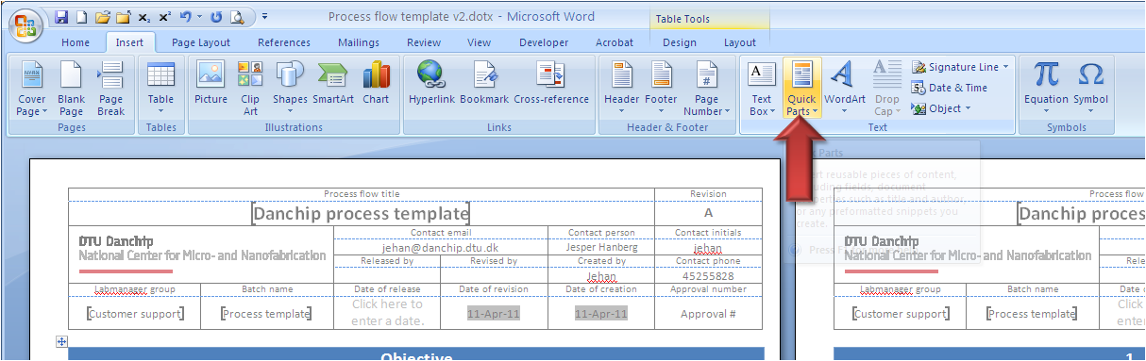
- Other document parts can be inserted the same way: Substrates, Figures, etc.
- The Content (TOC) on the last page is an option, but provides a nice overview for very long process flows

Substrates
Substrate | Orient. | Size |  | Doping/type | Polish | thickness | Box | Purpose | # | Sample ID
Silicon | <100> |  | 100 mm | n (Phos.) | SSP | 525 ±25 µm |  | Device wafers | 2 | S1-S2
Silicon | <100> |  | 100 mm | n (Phos.) | SSP | 525 ±25 µm |  | Test wafers | 1 | T1
Comments: Number of wafers is for illustration only

Figures
Figure | Caption | Step | Figure
 | After SiO2 dep  Not part of this process flow example | 2.1
 | After lithography | 3.5
 | After BHF etch  Not part of this process flow example | 4.1
 | After resist strip  Not part of this process flow example | 4.4
 | After lithography  Not part of this process flow example | 5.6
 | After metal deposition  Not part of this process flow example | 6.1
 | After lift-off  Not part of this process flow example | 6.2
Comments:Click here to enter text.

Step Heading | Equipment | Procedure | Comments
- Preparation |  |  | All wafers
- Wafer selection | Wafer box | Take the wafers from the storage and put them in a wafer box. | Note the wafer IDs in the batch traveler
- SiO₂ deposition |  |  | All wafers
  - Not part of this process flow example
- Lithography – standard |  |  | All wafers
- Surface treatment | BHF dip  Or  Oven:  HMDS – 2 | BHF dip for Si substrates (BHF: 30 sec, H₂O: 5 min)  HMDS treatment for Si, SiO₂, and Borofloat  Recipe:  01 | For Si, choose BHF or HMDS  HMDS priming can also be performed inline on Gamma spin coaters
- Coat wafers | Spin Coater: Gamma UV  Or  Spin coater:  Gamma e-beam & UV | Resist:  AZ 5214E  Spin:  30 s @ 4500 rpm (for 1.5 µm)  Softbake:  60 s @ 90 °C  Sequence gamma UV:  3410 DCH 100mm AZ5214E 1.5um  Sequence gamma ebeam & UV:  4110 DCH 100mm AZ5214E 1.5um | Inline HMDS priming:  Gamma UV: 3411  Gamma ebeam & UV: 4111  Resist thickness can be measured on FilmTek or ellipsometer
- Exposure | Aligner:  MA6-2 | Mask:  your mask  Exposure mode:  Soft contact  Exposure dose:  72 mJ/cm²  Exposure time:  6.5 s @ 11 mW/cm² | Further information is available on labadviser:  https://labadviser.nanolab.dtu.dk/index.php?title=Specific_Process_Knowledge/Lithography
- Develop | Developer: TMAH UV-lithography | Development in TMAH (AZ 726 MIF):  single puddle, 60 s  Sequence:  1002 DCH 100mm SP 60s
- Inspection | Optical microscope | Check pattern and alignment marks
- SiO₂ etch |  |  | All wafers
  - Not part of this process flow example
- Lithography – Lift off |  |  | All wafers
  - Not part of this process flow example
- Aluminum pattern |  |  | Only device wafers!!
  - Not part of this process flow example
- Linewidth measurement |  |  | All wafers
  - Not part of this process flow example

Contents
1 Preparation 3
1.1 Wafer selection 3
2 SiO₂ deposition 3
2.1 Not part of this process flow example 3
3 Lithography – standard 3
3.1 Surface treatment 3
3.2 Coat wafers 3
3.3 Exposure 3
3.4 Develop 3
3.5 Inspection 3
4 SiO₂ etch 3
4.1 Not part of this process flow example 3
5 Lithography – Lift off 3
5.1 Not part of this process flow example 3
6 Aluminum pattern 3
6.1 Not part of this process flow example 4
7 Linewidth measurement 4
7.1 Not part of this process flow example 4

